KASHIPUR MICHEAL MADHUSUDAN MAHAVIDYALAYA
(PERSONAL PROFILE)

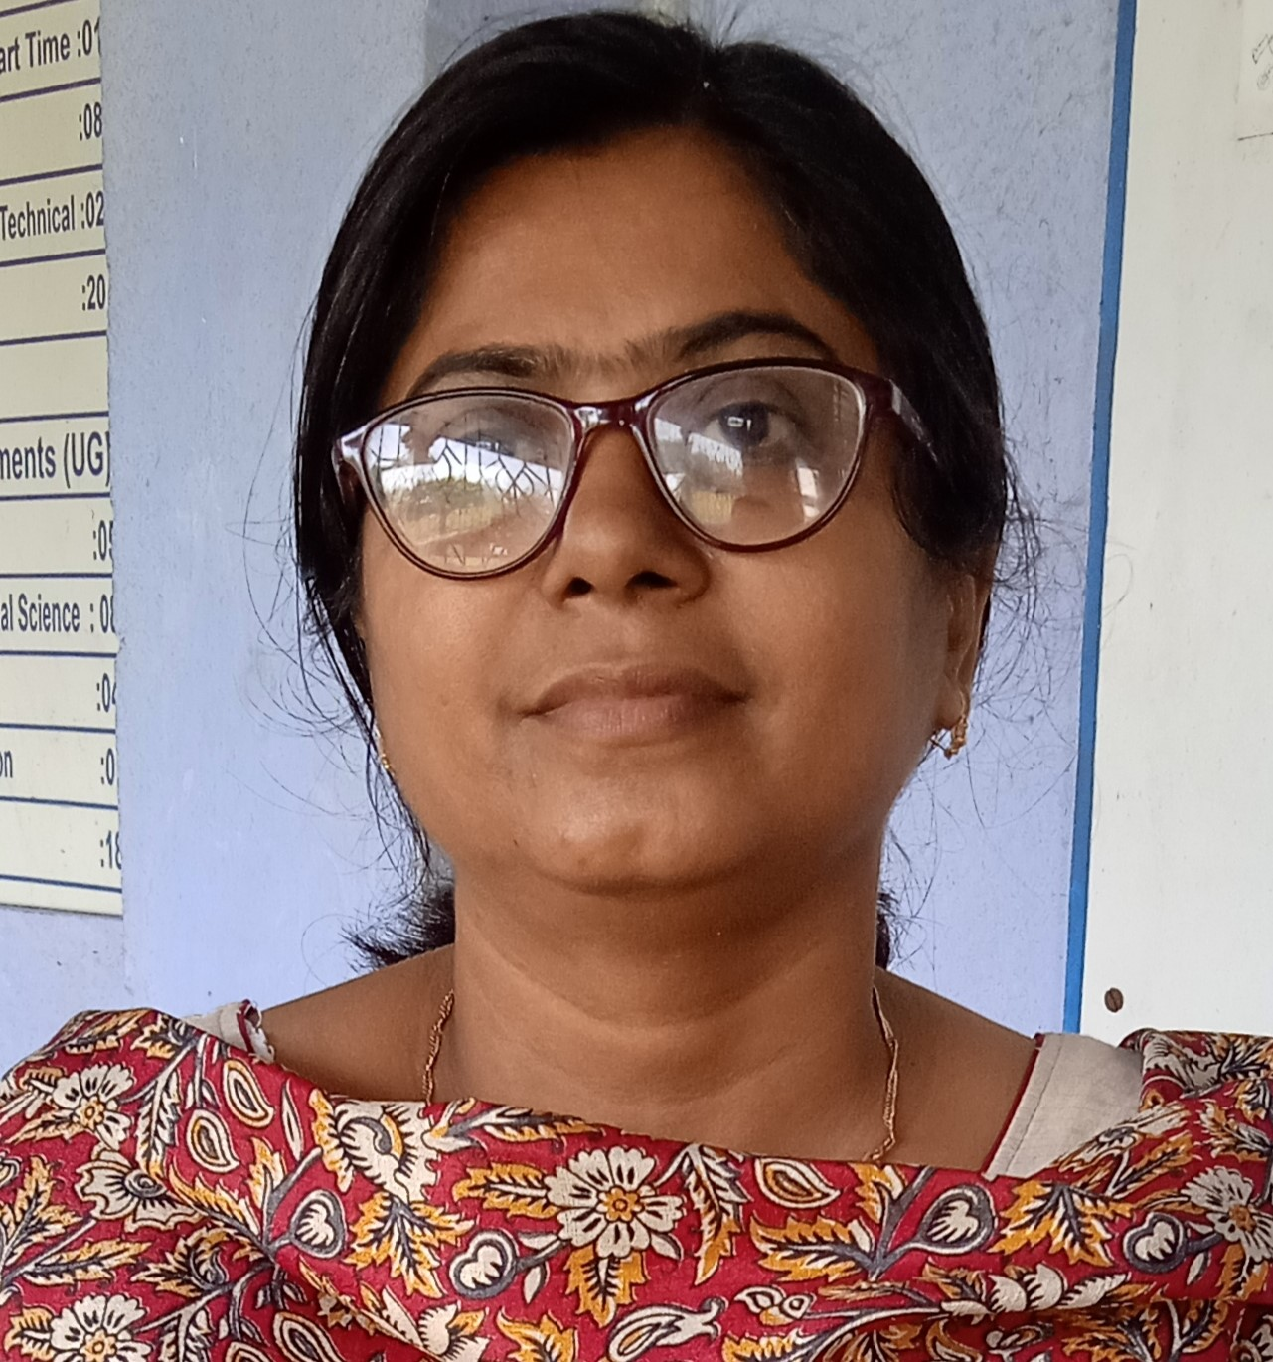

Name: Moutusi Saha
Designation: SACT
Date of Joining: 19.09.2003
e-mail: moutusisaha81@gmail.com

Educational Qualification:
- Graduation: Bengali Honours (Burdwan University)
- Post-graduation: Loko Sanskriti(Rabindra Bharati University)

State Level / National / International Conferences /Seminars /Workshops /Webinar Attended:
- Paper Presentations in Seminars / Conferences / Webinars
- Presented a paper entitlted ‘Jibon e bismoi Kavita rupasi bangla’ on 12-10-2-23 organized by Department of Bengali, Balarampur College, Sidho Kanho Birsa University

- Participation in Seminars / Conferences / Training Programmes / Workshop / Webinars
1. Completed One Month Refresher Course on “ Strategies For Evaluating Teaching Effectiveness” (SETE 2022), February-March 2022, Organised by Degree College Nala, Jamtara (An Affliated unit of S.K.M University, Dumka, In Association with National Vocational Training and Technology Research Institute(NVTTRI), Dhanbad, Jharkand
2. State Level Webinar: " Jonosashtho O Manbhum Sanskriti"Organized by Department of Bengali on 20th Sep 2020.
3. National Webinar: "Mahamari Itihaas O Uttaran,Shikkha khetre Bartomaan Manosik Sonkot" Organized by Bengali Department on 5th Jan 2021
4. International Webinar: " Lokayata Jibon O Lokosangeet" Organized by Music Department on 14th Sep 2020
5. International Webinar: " Loko Jiboner Sangeet: bhatiyali,Bihu,Baul"
6. National Webinar: "Bangla Ganer Sekal-Ekal O Bangla Loko songeeter Dhara" Organized by Department of Music on 29th june 2021
7. National Webiner:: " Rabindranather gaaner Otyadhunikota Ebong Prasongikota"
Organized by Department of Music on 12th july 2021

List of Research Papers published in National / International Journals / Books / Conference Proceedings with ISBN / ISSN / Impact Factor:
- Books:
- None
B)Journals:
1. None
C)Conference Proceedings:
1. None

Awards and Recognition:
- None

Areas of Specialization in Research / Teaching:
- Specialization in Teaching: None

- In Research: None

Teaching:
- Theory: Chanda,Saakto padavali,Madhya yuger kavya,Rabindra Sahitya..
- Practical: None
- Excursion / Field Survey: None

Invited Lecture / Foreign Visit:
1. None

Other Academic Activities:

- Board of Studies: None
- Course Design: None
- Paper Setter: None

Administrative Activities
Member of Grievance and Anti-Ragging Cell, Kashipur Michael Madhusudan Mahavidyalaya

Associated with Learned Bodies / Association / Society / Organization:

1. None

